**ASSIGNMENT 1 FRONT SHEET**

|  |  |  |  |
| --- | --- | --- | --- |
| **Qualification** | **BTEC Level 5 HND Diploma in Business** | | |
| **Unit number and title** | **Unit 30: Application Development** | | |
| **Submission date** |  | **Date Received 1st submission** |  |
| **Re-submission Date** |  | **Date Received 2nd submission** |  |
| **Student Name** |  | **Student ID** |  |
| **Class** |  | **Assessor name** |  |
| **Student declaration**  I certify that the assignment submission is entirely my own work and I fully understand the consequences of plagiarism. I understand that making a false declaration is a form of malpractice. | | | |
|  |  | **Student’s signature** |  |

**Grading grid**

|  |  |  |  |  |  |
| --- | --- | --- | --- | --- | --- |
| **P1** | **P2** | **P3** | **M1** | **M2** | **D1** |
|  |  |  |  |  |  |

|  |  |  |
| --- | --- | --- |
| **❒ Summative Feedback: ❒ Resubmission Feedback:** | | |
| **Grade:** | **Assessor Signature:** | **Date:** |
| **Internal Verifier’s Comments:** | | |
| **Signature & Date:** | | |

Task 1 – Software Requirements Specifications and Software Design

I. Introduction

1. Document Purpose

The objective of the Software Requirements Specification is to establish the requirements that FPT Corporation needs to fulfill to offer a platform that enables customers and bookstore owners to manage book purchases. To simplify and expedite the book selection, purchase, and checkout process for consumers, and to provide bookstore owners with a user and product database management system, it is imperative to develop a web-based platform for online book management and sales. This will lead to an increase in business revenue. By creating an account and logging in to the website, users can access all available books, view detailed book information, and conduct keyword searches. The system allows for book management and sales, as well as the addition, updating, and removal of books by staff members. The administrator has control over the account list.

2. Product Scope

The main goal of FPTBook is to provide a platform for book store customers and owners to manage their book purchases and sales in an efficient and convenient manner. By developing a web-based system, users will be able to easily choose, buy, and purchase books online, while proprietors can maintain their user and product databases. This will not only streamline and accelerate the process of book selection and purchase for customers, but also increase the revenue of the business. Additionally, the system allows users to create an account, log in, and browse all available books, search for books using keywords or phrases, and add desired books to their basket. Book store staff can use the system to add, update, and delete books, while administrators have authority over the account list. Overall, FPTBook aims to provide a comprehensive solution for managing and selling books online.

3. Intended Audience and Document Overview

The primary focus during the initial phases of the project's development will be on the FPTBook company's administrators and customers. This will allow them to monitor and oversee the progress of the project, which is why the project manager is also included in the document. Additionally, the document aims to provide clear guidance to testers, developers, and document writers to ensure a comprehensive understanding of the project's goals and objectives.

For customers, this document will provide an overview of the project's development, helping them gain a better understanding of the product being created.

For developers, the document will serve as a roadmap for the project's development, outlining its requirements and direction. This will enable them to make informed decisions about which features to add or remove, resulting in a more complete and refined product.

For professors, their input and feedback will be invaluable in improving the project. Drawing upon their extensive qualifications and experience, they will provide suggestions and recommendations that will be crucial in the project's development.

This document outlines several important aspects of the research, including the technology and tools used in the development of a website. The objective, scope, and potential users of the product are also discussed. The functions, features, and operations of the product are described in detail. The document also includes constraints related to user requirements, software, and hardware.

Moreover, the document includes diagrams and user interfaces to help visualize the product. It also highlights potential risks that may arise during project implementation. Overall, this document serves as a comprehensive guide for the development of the website, providing critical information and details to ensure a successful outcome.

4. Definitions, Acronyms and Abbreviations

|  |  |  |
| --- | --- | --- |
| Acronyms | Meaning | Definition |
| MVC | Model-View-Controller | A software design pattern that divides linked program logic into three interrelated pieces and is often used for building user interfaces. |
| UI | User interface | A user interface (UI) is the place where humans and machines interact in the industrial design discipline of human computer interaction. |
| UX | User experience | The method used by design teams to produce products that give consumers with meaningful and relevant experiences. |

|  |  |  |
| --- | --- | --- |
| UML | Unified Modeling Language | Object-oriented approaches employ a modelling language made up of graphic symbols to swiftly create information systems. |
| Use case diagram | Use case diagram | A method for describing functional needs. |
| Class diagram | Class diagram | A class diagram is a form of static structural diagram that depicts a system's structure by displaying the system's classes, properties, actions (or methods), and connections between objects. |
| ERD | Entities relationship  diagram | Entity set relationships maintained in a database |
| Bootstrap | Bootstrap | The most popular CSS Framework for designing flexible and mobile-first websites is Bootstrap. |

5. References and Acknowledgments

The author's team had already developed an application website related to the project and had gained the necessary expertise to accomplish it. Consequently, the team does not rely on any paper-based or online resources.

II. Overall Description

1. Product Overview

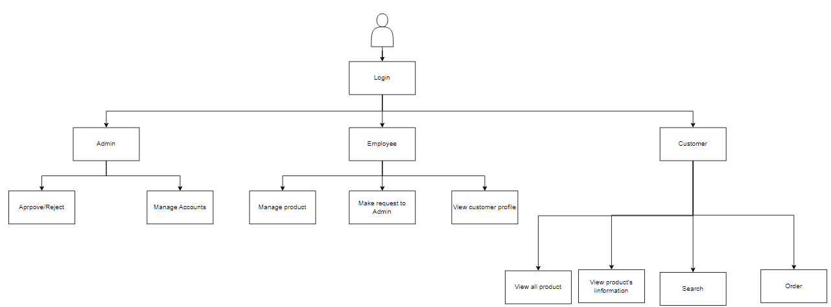

FPT Company aims to assist customers and bookstore owners in managing their book purchases through an online bookshop website. The website streamlines book inventory management for store owners and facilitates book search and purchase for customers. This system allows for book collection management, book information browsing, book purchasing, as well as book and employee account management (for administrators). The system is designed to accommodate three positions: administrator, employee, and user (customer).

2. Product Functionality

The program will be developed as an e-commerce website for selling books. Bookstores will have the software installed, and customers will be able to access the bookstore's website. FPTBook will be marketed as a sales tool for bookstores that streamlines the management of book sales.

Major junction of system

Admin

* Admin can login, logout
* Admin can update their information
* Admin can view customer’s profile
* Admin can change customer’s password (if it is needed)
* Admin can delete customer’s accounts
* Admin can view store owners’ profile
* Admin can change store owners’ password (if it is needed)
* Admin can approve or reject the new book category request made by the Store Owner

Customer

* Customer can login, logout or register their account
* Customer can send request to admin to change password
* Customer can view categories’ product
* Customer can view the product list
* Customer can view product’s detail (Name, image, price, categories, description, …)
* Customer can view their purchase history

Store Owner

* Store Owner can add, edit, search, delete products
* Store owner can login, logout or register their account
* Store Owner can search customer information by email.
* Store Owner can add a new category by sending request to admin.
* Store Owner can edit exited categories’ name.

3. Design and Implementation Constraints

a) Hardware design constraints

The hardware system for our project meets the following minimum system requirements:

* Microsoft Window XP or higher
* Intel I3 2nd Gen
* Minimum 2GB RAM
* Minimum 5GB free space

b) Software constraints

For the software system for our project will have to meet the following minimum requirements:

* SQL server manager
* Use framework Bootstrap, html, css for the Front-end design
* Use Visual Studio 2022 to code for the project

c) Other constraints

Time constraint: this report must be completed before 20/4/2023 and the project must be completed before 30/4/2023

* Language constraint: all the members in group must be knows English.
* All team members must ensure system security.
* Ensure privacy for each individual account of customers as well as managers.
* Make sure not to reveal the customer's password or account.
* Members strictly follow the direction of the leader, follow the orientation set out during the discussion.

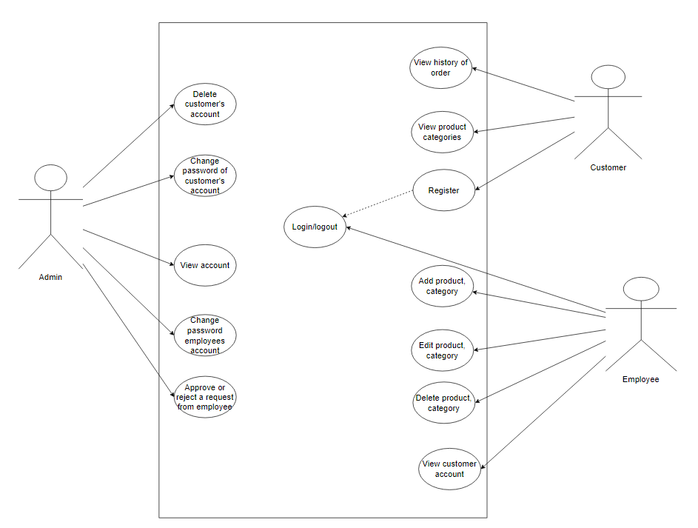

The system has three main users: admin, storeowner and customer. Admin and storeowner can log in with their existing accounts while customers need to register a new account if they don’t have one. Admin has the ability to manage the accounts of storeowners and customers. This includes changing passwords or deleting accounts. Storeowners are responsible for managing the products. They can add, edit, delete and view all the products and categories. Customers can view the products, categories and their order history.

3.3. Wireflow

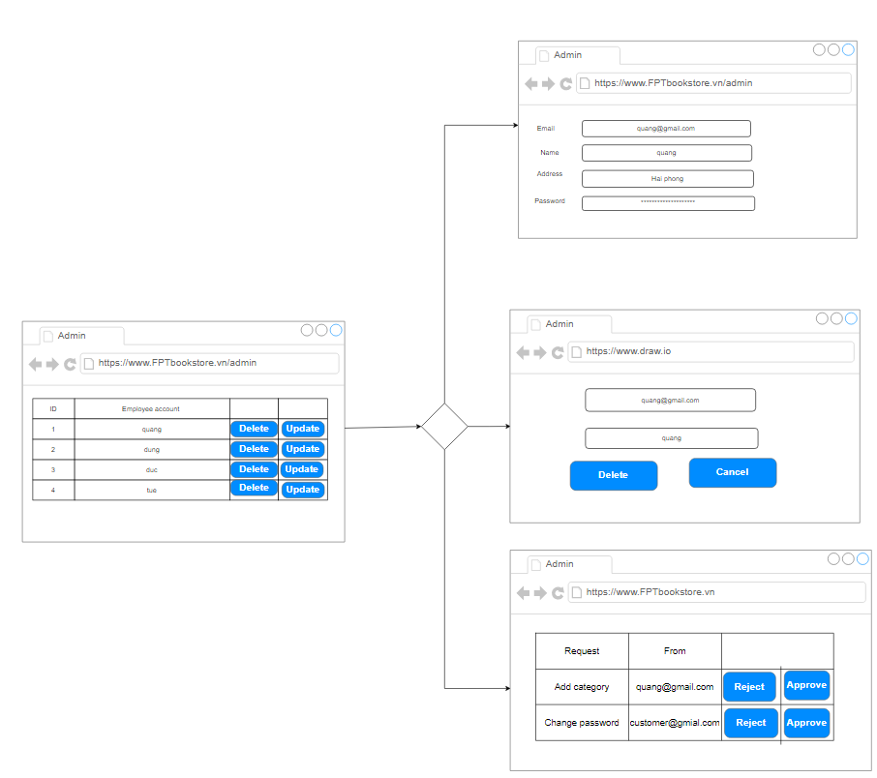

When logging in by an admin account, the admin page will view all the existed accounts in the database. Admin can edit profile and change password of store owner and customer accounts. Admin can also delete accounts. There are requests sent to admin from store owners and customers, admin can approve or reject that request.

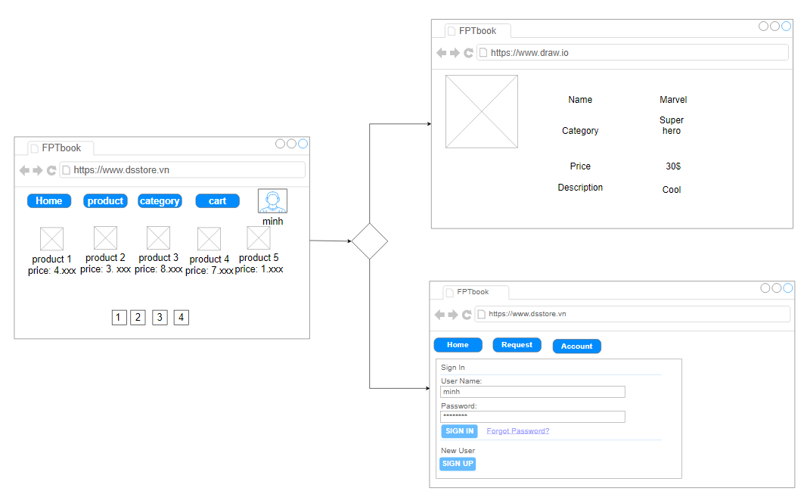

As a customer accessing the website, you will see the available products and their details. To add products to your cart, you will need to log in to your existing account or create a new one. Once the products are added to the cart, you can proceed to place the order.

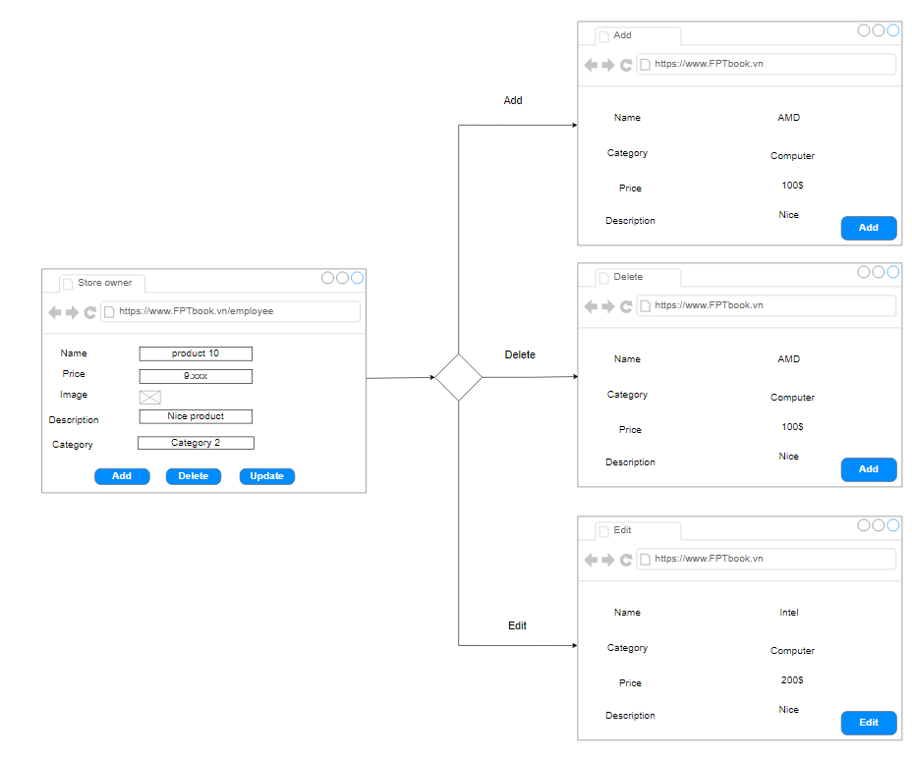

4. Technical design

4.1. ERD

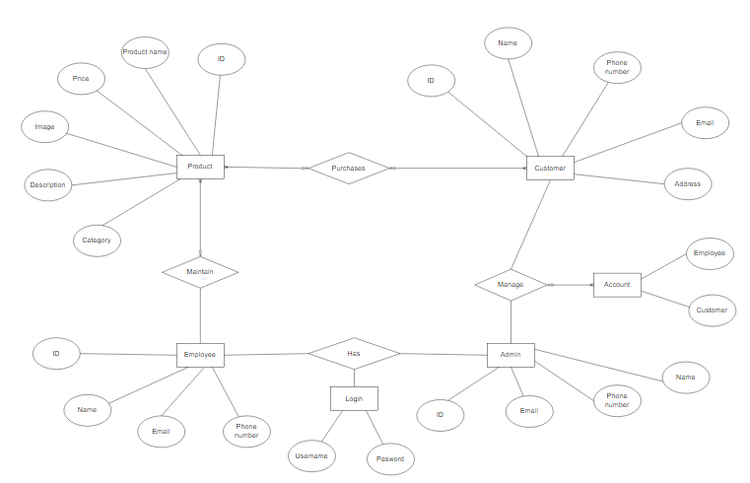

4.2. Class diagram

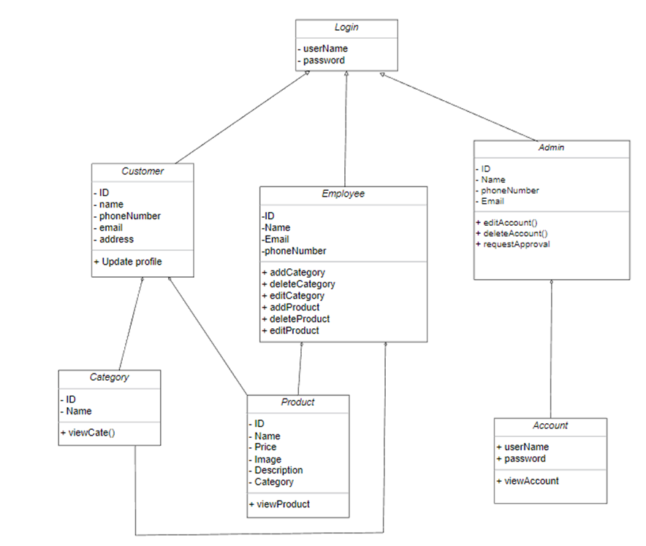

The diagram shows 7 classes. The Login class is used to access each role including customer, store owner and admin which represent the Customer, Storeowner and Admin classes. For the Customer class, users have the following functions: Update Profile, View all books and View all Categories. The Customer class is associated with the Books class and Categories class. For the Storeowner class, there are book management and category management functions including Add, Edit, Delete, View and send request to Admin. As an admin, users can manage customers and store owners accounts with functions Edit, Delete and View. An admin can also approve or reject requests from store owners.

4.3. Activity Diagram

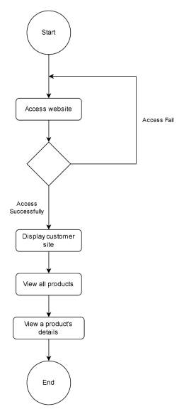

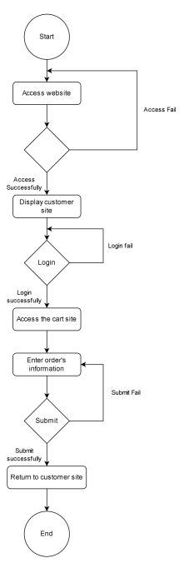

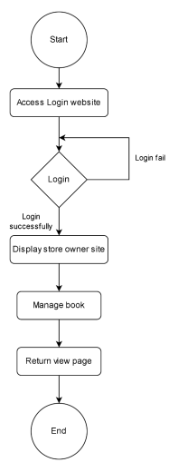

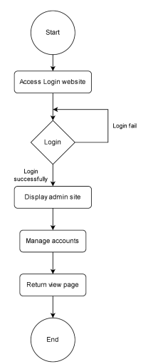

4.4. GANTT Chart

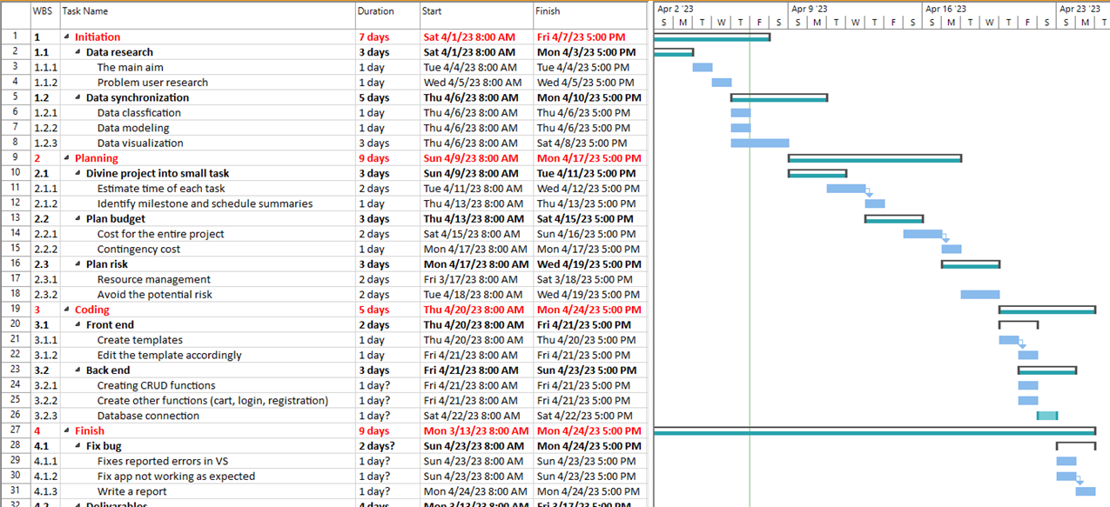

5. Risk Assessment

5.1. Risk Assessment

|  |  |  |  |  |  |  |  |  |  |  |
| --- | --- | --- | --- | --- | --- | --- | --- | --- | --- | --- |
|  | **P R E - M I T I G A T I O N** | | | **DEPARTMENT**  **/LOCATION** | **MITIGATIONS**  **/ WARNINGS / REMEDIES** | **P O S T - M I T I G A T I O N** | | | | |
| **RISK** | **RISK SEVERITY** | **RISK LIKELIHOOD** | **RISK LEVEL** |  |  | **RISK SEVERITY** | **RISK LIKELIHOOD** | **RISK LEVEL** | **ACCEPTABLE TO PROCEED?** | |
|  |  | **ACCEPTABLE**  **TOLERABLE**  **UNDESIRABLE**  **INTOLERABLE** | **IMPROBABLE**  **POSSIBLE**  **PROBABLE** | **LOW**  **MEDIUM**  **HIGH**  **EXTREME** |  |  | **ACCEPTABLE**  **TOLERABLE**  **UNDESIRABLE**  **INTOLERABLE** | **IMPROBABLE**  **POSSIBLE**  **PROBABLE** | **LOW**  **MEDIUM**  **HIGH**  **EXTREME** | **YES / NO** | |
| **1** | The amount of information is excessive, necessitating the use of the premium version. | Undesirable | Possible | Medium | Database | More funding for the initiative is being sought, as well as new methods to expand the database. | Undesirable | Improbable | Medium | Yes | |
| **2** | Due to the situation of the Covid-19 epidemic, the group could not discuss directly to make contributions as well as fully convey the content of their opinions. | Undesirable | Improbable | Medium | Any | The organization suggests adopting Google Meeting, Zoom, or other meeting applications as a contact option for business and meetings. | Undesirable | Improbable | Low | Yes | |
| **3** | NestJS stop supporting HTML. | Intolerable | Improbable | Medium | Frontend, Backend | Change to NodeJS or API.net if NodeJS is no longer supported. | Tolerable | Improbable | Low | Yes | |
| **4** | Because group members have various personal responsibilities during the work process, certain meetings and tasks may not be completed as planned. | Intolerable | Possible | High | Any | Other members should share the workload in order to perform responsibilities in lieu of the sick member. | Tolerable | Improbable | Low | Yes | |
| **5** | One of the collaborations has stopped enabling users to utilize the free versions of MySQL, NestJS, and HTML. | Intolerable | Improbable | Medium | Frontend, Backend,  Database | Requesting further funding for the project or switching to a different platform. | Undesirable | Improbable | Medium | No | |
| **6** | The frontend design is not suitable for displaying database information. | Tolerable | Proper | Medium | Frontend, Database,  Designer | While designing the website, the designer must collaborate with both the Frontend and Database divisions. | Acceptable | Improbable | Low | Yes | |
| **7** | Some members are not really good at NodeJs, maybe because they are not sure about the basics of NodeJs, or NodeJs is not their primary language | Intolerable | Possible | Medium | Any | Members with more experience can assist and advise others in completing their objectives. | Tolerable | Improbable | Medium | Yes | |
| **8** | One of the team members is ill and will not be able to finish the assignment on time. | Intolerable | Possible | High | Any | A member will work on all aspects of the website and, if required, take the place of the ailing member. | Tolerable | Improbable | Low | Yes | |
| **9** | The MVC model is mostly utilized in this project, although there are some issues with thinking and knowing about it; some people do not fully comprehend and utilize the  model. | Tolerable | Possible | Medium | Frontend, Backend, Database | Members with more experience can assist and advise others in completing their objectives. | Tolerable | Improbable | Low | Yes | |
| **12** | A team member contracted Covid-19 during work | Intolerable | Possible | High | Any | If required, healthy members will assist ailing members with their jobs. | Tolerable | Improbable | Low | Yes | |

Task 2 – Technologies evaluation

I. Design tools

1. Visual Paradigm



Visual Paradigm is a software modeling and diagramming tool that supports various modeling languages and notations, such as UML, BPMN, ERD, and SysML. It allows users to create and design diagrams, models, and documentation for software development, system engineering, and business processes.

One of the key benefits of Visual Paradigm is its ease of use and intuitive interface. Users can drag and drop elements onto the diagram canvas and use the context menu to create relationships between them. The software also provides a wide range of templates and examples to help users get started quickly.

Another notable feature of Visual Paradigm is its collaboration capabilities. Users can work on the same project simultaneously, and the software provides tools for version control, commenting, and feedback. It also integrates with various project management and development tools, such as JIRA and GitHub.

Visual Paradigm offers a comprehensive set of features for different types of modeling, including class diagrams, use case diagrams, sequence diagrams, activity diagrams, and more. It also supports reverse engineering, code generation, and round-trip engineering, making it useful for both designing and implementing software systems.

2. Draw.io

Draw.io is a free and open-source online diagramming tool that allows users to create flowcharts, diagrams, and other visual representations. It is a great tool for creating professional-looking diagrams without the need for any specialized software or design skills.

One of the biggest advantages of draw.io is its ease of use. The user interface is intuitive and easy to navigate, and there are a wide range of templates and pre-made shapes to choose from, making it easy to create a diagram quickly. It also integrates well with other software such as Google Drive, Confluence, and Jira, which makes it a useful tool for collaborative projects.

Draw.io also offers a high level of customization. Users can change the color, size, and shape of objects, add text and images, and even create their own custom shapes. This flexibility makes it a versatile tool for a variety of different diagramming needs.

One potential downside of draw.io is that it can be a bit overwhelming for users who are not familiar with diagramming tools. While the interface is intuitive, there are many different features and options to explore, which can be a bit daunting at first. (Azure, 2022)

3. Conclude which tools will be used for the design of the application

Although every tool has its own set of strengths and weaknesses, draw.io and Visual Paradigm are especially proficient in the area of design. In my project, I plan to utilize both tools to leverage the strengths of each one. They both excel in user interface design, and are also flexible and easy to work with due to their lightweight nature.

II. Front End technology stack

1. Front End Programming Language

a) JavaScript



JavaScript is a popular and versatile programming language used for web development, server-side development, and mobile app development. Like any programming language, JavaScript has its advantages and disadvantages.

Advantages of JavaScript:

* Easy to learn: JavaScript is a simple and easy-to-learn programming language, which makes it accessible to beginners and allows for faster development.
* Interactivity: JavaScript allows for dynamic, interactive web applications that can respond to user actions and events in real-time, without the need for a page refresh.
* Wide browser support: JavaScript is supported by all major web browsers, which means that it can be used for cross-browser development.
* Flexibility: JavaScript can be used for a wide range of applications, including client-side scripting, server-side scripting, and mobile app development.
* Large developer community: The large and active JavaScript developer community provides a wealth of resources, libraries, and frameworks that can be used to accelerate development.

Disadvantages of JavaScript:

* Security: Because JavaScript runs on the client-side, it can be vulnerable to security risks such as cross-site scripting (XSS) attacks.
* Browser inconsistencies: Different browsers may interpret JavaScript code differently, leading to inconsistencies in how web applications are displayed and function across different browsers.
* Performance: JavaScript can be slower than other programming languages due to its dynamic nature and the fact that it is interpreted rather than compiled.
* Limited scalability: JavaScript may not be the best choice for large, complex applications with high traffic and scalability requirements.
* Lack of type safety: JavaScript is a loosely typed language, which means that type safety is not enforced. This can lead to errors and bugs that may be difficult to debug and fix.

Overall, JavaScript is a powerful and versatile programming language with many advantages, but it also has its limitations and drawbacks that developers should be aware of when using it for web or mobile app development. (Anh, 2022)

b) React



React is a popular JavaScript library for building user interfaces, and it has several advantages and disadvantages.

Advantages:

* Virtual DOM: React uses a virtual DOM, which updates only the parts of the actual DOM that have changed. This results in faster rendering and better performance compared to traditional DOM manipulation.
* Component-based architecture: React uses a component-based architecture, which allows developers to create reusable UI components. This makes it easy to manage large-scale applications and maintain code.
* Rich ecosystem: React has a rich ecosystem with a large number of third-party libraries and tools. This makes it easy for developers to find solutions for different use cases and add features to their applications.
* SEO-friendly: React has server-side rendering capabilities, which makes it more SEO-friendly compared to other single-page application frameworks.

Disadvantages:

* Steep learning curve: React has a steep learning curve, especially for beginners who are not familiar with modern web development concepts and tools.
* Complex setup: Setting up a React project can be complex, especially for developers who are new to the ecosystem.
* JSX syntax: React uses a JSX syntax, which can be confusing for developers who are used to writing HTML.
* Unopinionated: React is unopinionated, which means that developers have to make choices about which tools and libraries to use. This can lead to decision fatigue and make it harder to maintain consistency across projects.

Overall, React is a powerful tool for building modern web applications, but it has a few trade-offs that developers should consider when choosing it for their projects. (Mitchell, 2022)

c) HTML/CSS

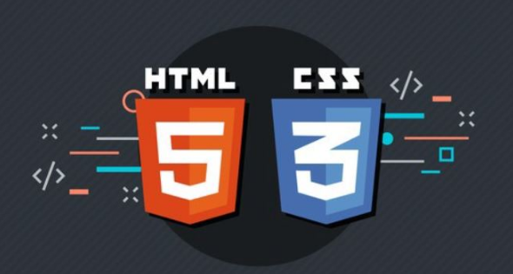

HTML (Hypertext Markup Language) and CSS (Cascading Style Sheets) are the two fundamental technologies used to create websites. They work together to structure and style web content (Duc, 2022). Here are some advantages and disadvantages of using HTML/CSS:

Advantages:

* Easy to learn: HTML and CSS are relatively easy to learn and use. With a basic understanding of the language, you can create simple web pages quickly.
* Accessibility: HTML and CSS are accessible to a wide range of people, including those with disabilities. Proper use of HTML and CSS can help make websites more accessible to those who use screen readers and other assistive technologies.
* Search engine optimization (SEO): Properly using HTML and CSS can help websites rank higher in search engines. By organizing content with HTML and properly using CSS to style it, search engines can more easily understand what a website is about and improve its ranking.
* Separation of content and style: HTML is used to structure web content, while CSS is used to style it. This separation makes it easier to maintain and update a website's design without affecting the content.

Disadvantages:

* Limited interactivity: HTML and CSS are primarily used for creating static web pages. While HTML5 and CSS3 have introduced more interactivity features, they are still limited in comparison to other technologies such as JavaScript and React.
* Limited functionality: HTML and CSS are designed to structure and style web content. They do not provide the functionality that more advanced programming languages do, such as back-end processing and dynamic content.
* Browser compatibility issues: Different browsers interpret HTML and CSS differently, which can result in compatibility issues. This can be especially problematic for older browsers.
* Steep learning curve for advanced features: While HTML and CSS are relatively easy to learn, mastering advanced features and techniques can take time and practice. This can be especially true when trying to achieve complex layouts and designs.

2. JavaScript/Framework

a) jQuerry



Advantages of jQuery:

* Simplified syntax: jQuery provides a simplified syntax for many of the commonly used JavaScript functions, making it easier and faster to write code.
* Cross-browser compatibility: jQuery can help make web pages more compatible across different browsers, as it is designed to work with many different browsers.
* Extensibility: jQuery is highly extensible, with many plugins and modules available to enhance its functionality.
* AJAX support: jQuery provides excellent support for AJAX (Asynchronous JavaScript and XML), making it easy to send and receive data asynchronously without having to reload the entire page.
* DOM manipulation: jQuery provides an easy way to manipulate the Document Object Model (DOM) of a web page, allowing for dynamic changes to be made to the page without the need for a full reload.

Disadvantages of jQuery

* Performance: jQuery can sometimes be slower than writing pure JavaScript, especially when using complex animations or large data sets.
* Learning curve: While the syntax is simplified, learning jQuery can still be a challenge, especially for beginners.
* Dependency: Using jQuery requires adding an additional library to your code, which can add to the overall size of your web page and potentially slow down load times.
* Over-reliance: Developers may become too reliant on jQuery and neglect to learn pure JavaScript, which can limit their ability to work on projects without the library.

(Nguyen, 2023)

b) ReactJS



ReactJS is a popular JavaScript library that is used for building user interfaces (Linh, 2023). Here are some of its advantages and disadvantages:

Advantages:

* Component-based architecture: ReactJS is based on the concept of reusable components, which makes it easier to build and maintain complex user interfaces.
* High performance: ReactJS uses a virtual DOM, which allows it to update only the necessary parts of the user interface, resulting in faster rendering times.
* Large community: ReactJS has a large and active community of developers, which means there are many resources, libraries, and tools available to help developers build and maintain their applications.
* Easy to learn: ReactJS is relatively easy to learn and has a low barrier to entry, making it accessible to developers of all skill levels.
* Cross-platform: ReactJS can be used to build applications for a variety of platforms, including web, mobile, and desktop.

Disadvantages:

* Steep learning curve: While ReactJS is relatively easy to learn, it can be challenging for developers who are not familiar with functional programming concepts.
* JSX syntax: JSX, the syntax used in ReactJS, can be difficult to read and write for some developers, especially those who are used to writing plain HTML.
* Boilerplate code: ReactJS requires developers to write more code than some other frameworks or libraries, which can make development slower and more tedious.
* Poor documentation: Some developers have reported that the ReactJS documentation can be difficult to navigate and understand, which can make it harder to learn and use effectively.
* Not a complete solution: ReactJS is primarily a library for building user interfaces, so developers may need to use additional tools and libraries to build a complete application.

3. CSS Framework

a) Bootstrap

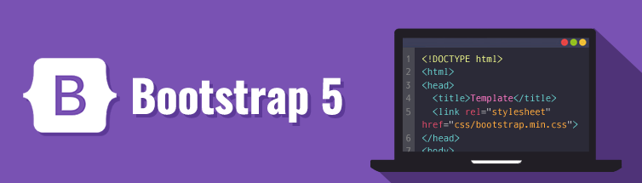

Bootstrap is a popular front-end framework that enables the development of responsive and mobile-first websites (Dung, 2022). Here are its advantages and disadvantages:

Advantages:

* Responsive design: Bootstrap is known for its responsive design. It provides a mobile-first approach to web development, meaning that websites built using Bootstrap are automatically optimized for mobile devices.
* Consistent styling: Bootstrap provides a set of pre-built components that offer a consistent look and feel across different parts of the website.
* Time-saving: Using Bootstrap can significantly reduce development time as it provides a library of ready-made components that can be easily customized to fit the specific needs of the project.
* Cross-browser compatibility: Bootstrap is compatible with most popular browsers, including Chrome, Firefox, Safari, and Internet Explorer.
* Accessibility: Bootstrap provides accessibility features that can help make websites more accessible to users with disabilities.

Disadvantages:

* Over-reliance on pre-built components: While Bootstrap provides a great library of pre-built components, over-reliance on them can lead to websites looking generic and lacking in personality.
* Bloated code: Bootstrap is a large framework, and using it can result in bloated code, which can slow down website performance.
* Learning curve: Although Bootstrap is relatively easy to learn, it can still take some time to master all its features and customization options.
* Limited flexibility: Since Bootstrap follows a specific set of design patterns, it may be challenging to implement certain unique designs that go beyond its default styling.
* Dependency on jQuery: Bootstrap relies on jQuery for some of its core functionalities, which can add an extra layer of complexity to the project and increase loading times.

4. Conclude which Front End technologies will be used for the development